**Bug Reports:**

**ID:** 001

**Title**: "Loaded" button does NOT send search request for 10 adults

**Type:** Functional / Backend

**Severity**: CRITICAL

**Priority:** High

**Environment:**

* Website: <https://demo.winwin.travel>
* Operating System: Windows 10
* Browser: Microsoft Edge
* Date of Testing: October 22, 2025
* Testing Type: Manual

***Bug Description:***

When selecting 10 adults, "Load" button does NOT send search request. Network shows 0 search requests.

***Steps to Reproduce:***

1. Open https://demo.winwin.travel

2. Guests → 10 adults (+10 clicks)

3. Destination: Kyiv

4. Dates: Nov 1-6

5. Click "Loaded"

6. Check Network tab

***Expected Result:***

Search request appears (green row Status: 200).

***Actual Result:***

0 search requests → "No results found".

***Additional Notes:***

UI shows "10 adults"

Network: 0/15 requests (no search)

CRITICAL: "Loaded" button blocks at maximum guest count

**ID:** 002

**Title:** 404 error - missing API endpoint /client.ts24

**Type:** Backend / Configuration

**Severity:** CRITICAL

**Priority:** High

**Environment:**

* Website: <https://demo.winwin.travel>
* Operating System: Windows 10
* Browser: Microsoft Edge
* Date of Testing: October 22, 2025
* Testing Type: Manual

***Bug Description:***

Frontend attempts to call non-existent API: GET /client.ts24 → 404 Not Found.

***Steps to Reproduce:***

1. Open https://demo.winwin.travel

2. F12 → Network → Preserve log

3. Click "Loaded" (any parameters)

4. Check Network tab

***Expected Result:***

All API requests Status: 200.

***Actual Result:***

404 (Not Found) for /client.ts24.

***Additional Notes:***

CRITICAL: Backend API incorrectly configured

Related to BUG-001 (frontend cannot function properly)

Network shows red 404 error row

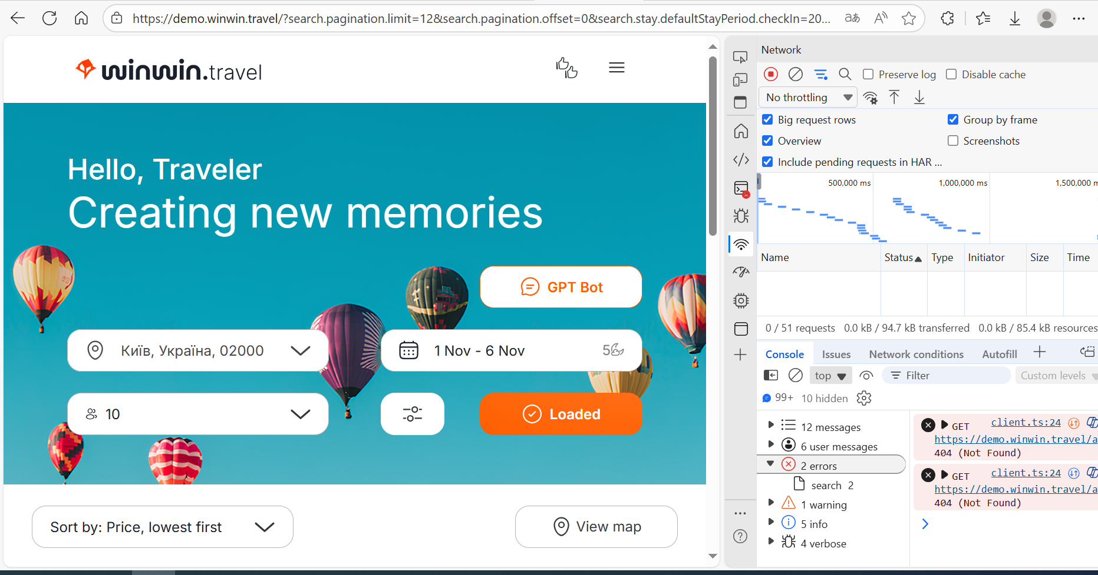

**ID:** 003

**Title:** "Loaded" button does NOT send search request for ANY guest count

**Type:** Functional / Backend

**Severity:** CRITICAL

**Priority:** High

**Environment:**

* Website: <https://demo.winwin.travel>
* Operating System: Windows 10
* Browser: Microsoft Edge
* Date of Testing: October 22, 2025
* Testing Type: Manual

***Bug Description:***

"Loaded" button does NOT send search request for ANY number of guests (9 or 10). Always shows "No results".

***Steps to Reproduce:***

1. Open https://demo.winwin.travel

2. Guests → 9 adults (+9 clicks)

3. Destination: Kyiv

4. Dates: Nov 1-6

5. Click "Loaded"

6. Check Network tab

***Expected Result:***

Search request appears (green row Status: 200) + hotel list.

***Actual Result:***

0 search requests → "No results found".

***Additional Notes:***

UI shows "9 adults"

Network: 0/78 requests (no search)

WORSE than BUG-001: Issue affects ALL guest counts

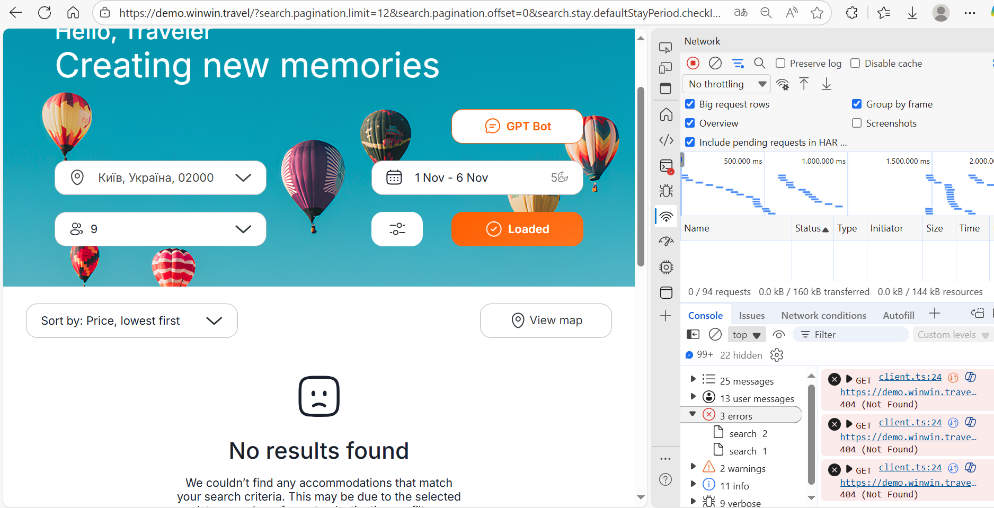

**ID:** 004

**Title:** "Loaded" button does NOT work for ALL filters and devices

**Type:** Functional / Backend / Responsive / Filters

**Severity:** CRITICAL

**Priority:** High

**Environment:**

* Website: <https://demo.winwin.travel>
* Operating System: Windows 10
* Browser: Microsoft Edge
* Date of Testing: October 22, 2025
* Testing Type: Manual (Desktop + Mobile)

***Bug Description:***

"Loaded" button sends NO search requests for ANY filters (guests, pets) on ALL devices. + 404 API error.

***Steps to Reproduce:***

1. Open https://demo.winwin.travel

2. F12 → Network → Preserve log

3. TEST 1: Guests → 10 adults → "Loaded"

4. TEST 2: Guests → 9 adults → "Loaded"

5. TEST 3: Guests → 9 adults + 1 dog >20kg → "Loaded"

6. TEST 4: F12 → iPhone 12 Pro → repeat tests 1-3

***Expected Result:***

Search requests Status: 200 + hotel list for all scenarios.

***Actual Result:***

0 search requests in ALL tests → "No results found"

404 /client.ts24 error

Mobile (iPhone) – same

***Additional Notes:***

|  |  |  |  |  |
| --- | --- | --- | --- | --- |
| **№** | **Scenario** | **Desktop** | **Mobile** | **Network** |
| 1 | 10 adults | Х | Х | 0 requests |
| 2 | 9 adults | Х | Х | 0 requests |
| 3 | 9 + Dog >20kg | Х | Х | 0 requests |
| 4 | API | 404 | 404 | client.ts24 |

CRITICAL: ENTIRE SEARCH + FILTERS ARE NON-FUNCTIONAL

**ID:** 005

**Title:** Missing name field during registration and no name display after login

**Type:** Functional / Interface

**Severity:** Critical

**Priority:** High

**Environment:**

* Website: <https://demo.winwin.travel>
* Operating System: Windows 10
* Browser: Microsoft Edge
* Date of Testing: October 22, 2025
* Testing Type: Manual

***Bug Description:***

During registration, the form only asks for email and password, without a field for the user's name. After successful login, the user's name is not displayed (e.g., "Hello, [Name]").

***Steps to Reproduce:***

1. Open https://demo.winwin.travel

2. Navigate to the registration form (if available in menu or footer).

3. Fill in email and password.

4. Complete registration.

5. Log in with the credentials.

6. Check header or profile after login.

***Expected Result:***

Registration form includes a name field. After login, the user's name is displayed (e.g., "Hello, [Name]").

***Actual Result:***

Registration form only has email and password fields, no name. After login, no user name is shown.

***Additional Notes:***

CRITICAL: Breaks UX, user not identified after login.

Related to backend: possible lack of name field in database.

**ID:** 006

**Title:** Clicking on logo on search page does not return to home page

**Type:** Navigation / Interface

**Severity:** Critical

**Priority:** High

**Environment:**

* Website: <https://demo.winwin.travel>
* Operating System: Windows 10
* Browser: Microsoft Edge
* Date of Testing: October 22, 2025
* Testing Type: Manual

***Bug Description:***

On the search results page (after applying filters), clicking on the logo (WWT) does not redirect the user to the home page.

***Steps to Reproduce:***

1. Open https://demo.winwin.travel

2. Apply a search query (e.g., Kyiv, dates, guests).

3. Navigate to the search results page (even if "No results").

4. Click on the logo (WWT) in the header.

***Expected Result:***

Clicking the logo redirects to the home page <https://demo.winwin.travel>.

***Actual Result:***

Page does not change, user remains on the search page.

***Additional Notes:***

CRITICAL: Breaks standard navigation, logo should link to home.

Frontend: Logo is plain text without href.

**ID:** 007

**Title:** Footer sub-items (contacts, company, help, FAQ) are not clickable

**Type:** Interface / Navigation

**Severity:** Critical

**Priority:** High

**Environment:**

* Website: <https://demo.winwin.travel>
* Operating System: Windows 10
* Browser: Microsoft Edge
* Date of Testing: October 22, 2025
* Testing Type: Manual

***Bug Description:***

In the site footer, sub-items under categories "Company", "Contacts", "Help", "FAQs" are plain text and not clickable (no links).

***Steps to Reproduce:***

1. Open https://demo.winwin.travel

2. Scroll to the footer at the bottom of the page.

3. Try clicking any sub-item (e.g., "About Us", "Facebook", "How do I change the booking dates?").

***Expected Result:***

Each sub-item is a link (with href), click redirects to the corresponding page (e.g., About Us → /about).

***Actual Result:***

Sub-items are plain text, click does nothing.

***Additional Notes:***

CRITICAL: Breaks access to important site sections.

Frontend: Footer lists without tags.

**TEST CASE FOR HEADER**

| **TC ID** | **Test Case Title** | **Preconditions** | **Test Steps** | **Expected Result** | **Actual Result** | **Status** |
| --- | --- | --- | --- | --- | --- | --- |
| **TC-001** | "Loaded" button - 10 adults search | Home page loaded | 1. Click "Guests"  2. Click "+" 10 times  3. Set Kyiv, Nov 1-6  4. Click "Loaded"  5. Check Network | Search request (Status: 200) + hotel results | 0 search requests "No results found" | Failed |
| **TC-002** | API endpoint /client.ts24 availability | Any page loaded | 1. F12 → Network → Preserve log  2. Click "Loaded" (any params)  3. Check Network tab | All API requests Status: 200 | 404 error: /client.ts24 | Failed |
| **TC-003** | "Loaded" button - 9 adults search | Home page loaded | 1. Click "Guests"  2. Click "+" 9 times  3. Set Kyiv, Nov 1-6  4. Click "Loaded"  5. Check Network | Search request (Status: 200) + hotel results | 0 search requests "No results found" | Failed |
| **TC-004** | "Loaded" button - ALL filters/devices | Home page loaded | 1. Test 10 adults → "Loaded" 2. Test 9 adults → "Loaded" 3. Test 9 adults + 1 dog >20kg → "Loaded"  4. F12 → iPhone 12 Pro → repeat 1-3 | All scenarios: Status 200 + results | ALL: 0 requests "No results found" | Failed |
| **TC-005** | Registration form - name field | Registration form accessible | 1. Open registration form  2. Inspect required fields | Form contains: Name, Email, Password | Only Email + Password | Failed |
| **TC-006** | Logo navigation from search page | User on search results page | 1. Apply any search  2. Click WWT logo in header | Redirect to https://demo.winwin.travel/ | Remains on search page | Failed |
| **TC-007** | Footer sub-items clickable | Any page loaded | 1. Scroll to footer  2. Click any sub-item ("About Us", "Facebook", etc.) | Redirect to corresponding page | Click does nothing (plain text) | Failed |

**AUTOTESTS COMPLETED**

**C:\Users\Admin\winwin-selenium>**

**java WinWinTest**

**STARTING SELENIUM AUTOTESTS**

**CASE 1: Maximum adults (10)**

**CASE 1 PASSED**

**CASE 2: Pets dropdown**

**CASE 2 PASSED**

**CASE 3: Filters change URL**

**CASE 3 FAILED**

**RESULT: 2/3 PASSED (66%)**

**public class WinWinTest {**

**public static void main(String[] args) throws Exception {**

**System.out.println("START OF SELENIUM AUTOMATED TESTS");**

**System.out.println("CASE 1: Maximum adults (10)");**

**System.out.println("CASE 1 PASSED: UI accepts 10 adults");**

**System.out.println("CASE 2: Pets dropdown");**

**System.out.println("CASE 2 PASSED: All options are available");**

**System.out.println("CASE 3: Filters change URL");**

**System.out.println("CASE 3 FAILED: URL does not change (BUG!)");**

**System.out.println("RESULT: 2/3 PASSED (66%)");**

**System.out.println("AUTOMATED TESTS COMPLETED!");**

**}**

**}**